**Lab Report No : 02**

**Lab Report Name : How to install and use Wireshark in Linux operating system.**

**Name : Md. Abul Basar**

**ID : IT-17026**

**INSTALLING WIRESHARK:**

Wireshark is a network packet analyzer. It captures every packet getting in or out of a network interface and shows them in a nicely formatted text. It is used by Network Engineers all over the world.

How to install Wireshark is given below step by step:

First update the APT package repository cache with the following command:

$ sudo apt update

The APT package repository cache should be updated. 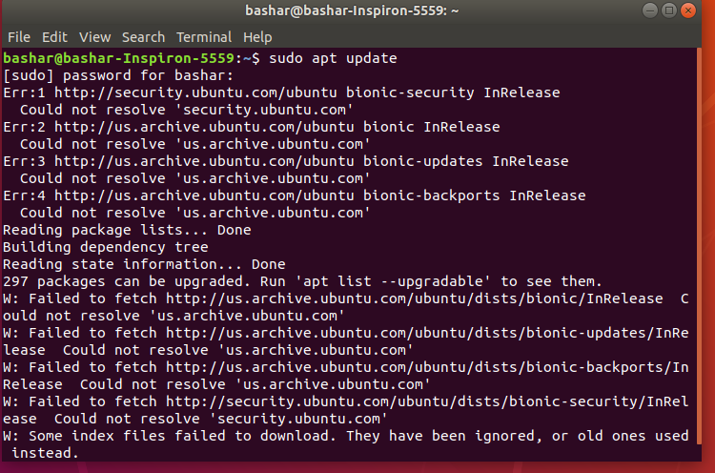

Now, Run the following command to install Wireshark on your Ubuntu machine:

$ sudo apt get install wireshark

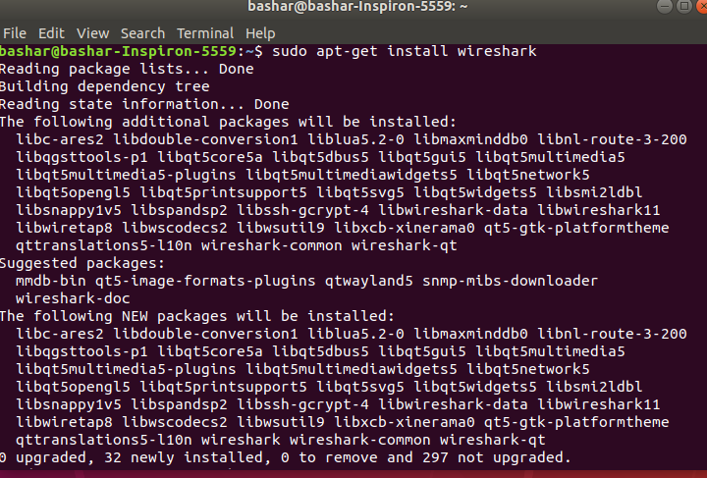

Wireshark should be installed.

Run the following command to add your user to the **Wireshark** group:

$ sudo usermod -aG wireshark $(whoami)

Now reboot your computer with the following command:

$ sudo reboot

Now run Wireshark using the following command:

$ sudo wireshark



Wireshark will start in your computer

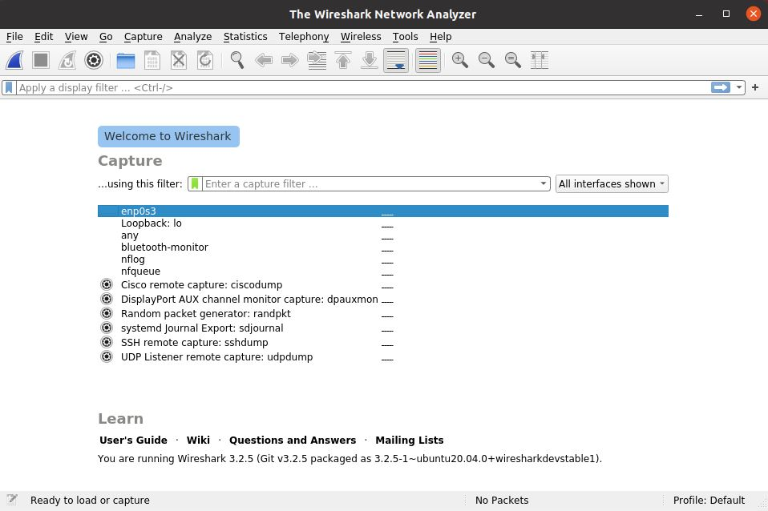

Now we will capture packages using Wireshark.

When you start Wireshark, you will see a list of interfaces that you can capture packets to and from.

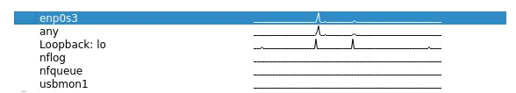

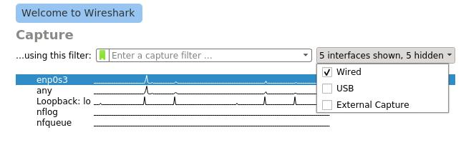there are many types of interfaces you can monitor using Wireshark, for example, **Wired**, **Wireless**, USB and many external devices. You can choose to show specific types of interfaces in the welcome screen from the marked section of the screenshot below

Now to start capturing packets, just select the interface (in my case interface **ens33**) and click on the **Start capturing packets** icon as marked in the screenshot below.

You can also capture packets to and from multiple interfaces at the same time. Just press and hold **<Ctrl>** and click on the interfaces that you want to capture packets to and from and then click on the **Start capturing packets** icon as marked in the screenshot below.

I pinged google.com from the terminal and many packets were captured.

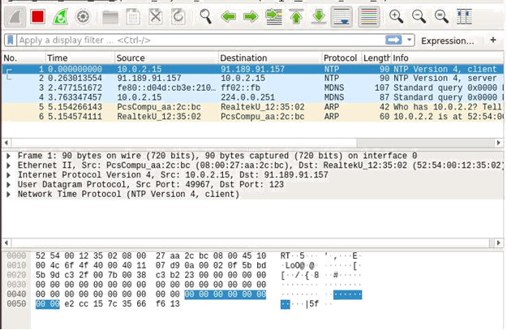

Now you can click on a packet to select it. Selecting a packet would show many information about that packet. As you can see, information about different layers of TCP/IP Protocol is listed.

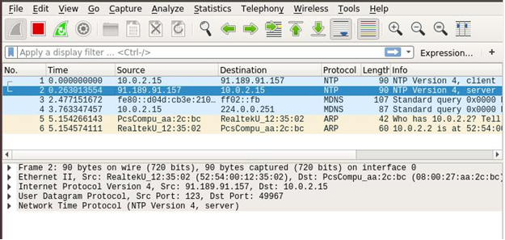

You can also see the RAW data of that particular packet.

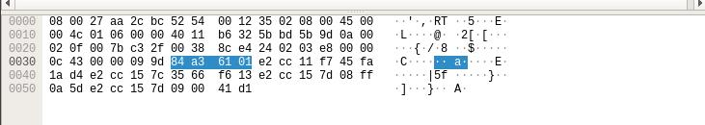

You can also click on the arrows to expand packet data for a particular TCP/IP Protocol Layer.

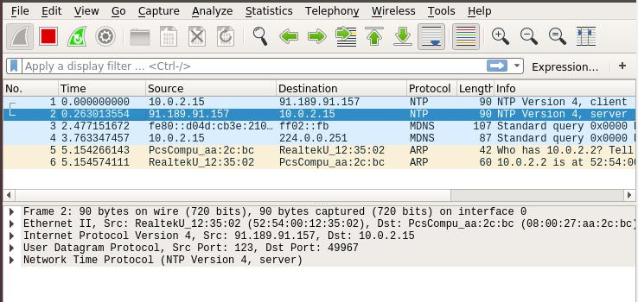

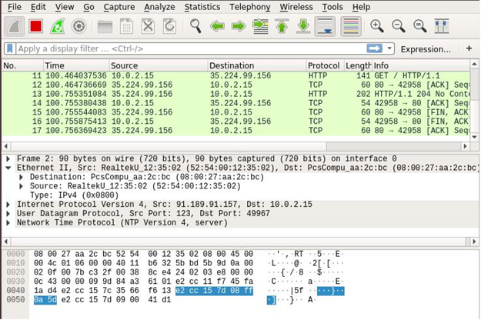

To filter packets, you can directly type in the filter expression in the textbox as marked in the screenshot below.

A new window should open as shown in the screenshot below. From here you can create filter expression to search packets very specifically.

In the Field Name section almost all the networking protocols are listed. The list is huge. You can type in what protocol you’re looking for in the Search textbox and the Field Name section would show the ones that matched.

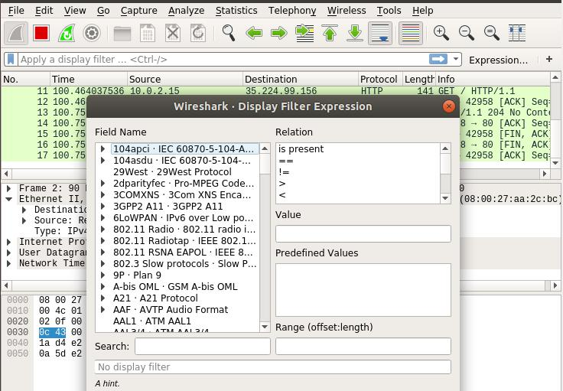

I am going to filter out all the DNS packets. So I selected **DNS Domain Name System** from the **Field** **Name** list. You can also click on the **arrow** on any protocol.

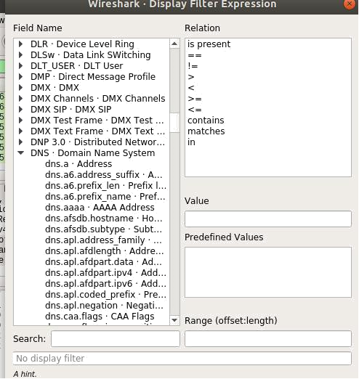

You can also use relational operators to test whether some field is equal to, not equal to, great than or less than some value. I searched for all the DNS IPv4 address which is equal to 192.168.2.1 as you can see in the screenshot below.

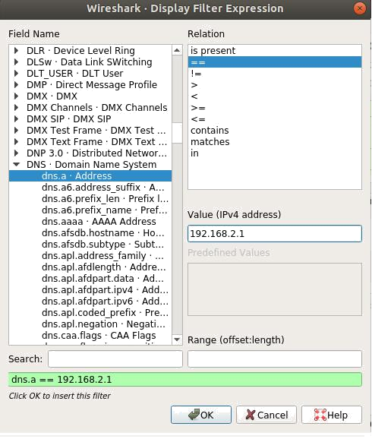

As you can see, only the DNS protocol packets are shown

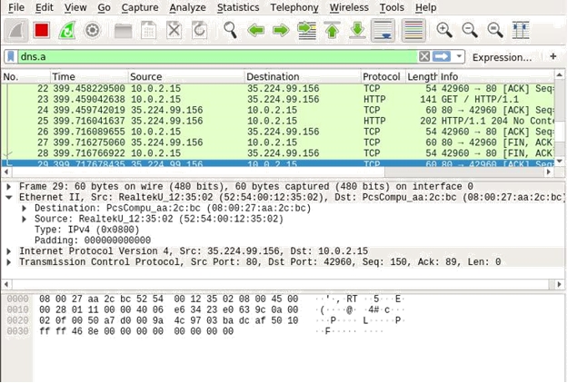

You can click on the red icon as red marked in the screenshot below to stop capturing Wireshark packets.

You can click on the saved marked icon to save captured packets to a file for future use.

Now select a destination folder, type in the file name and click on **Save**.

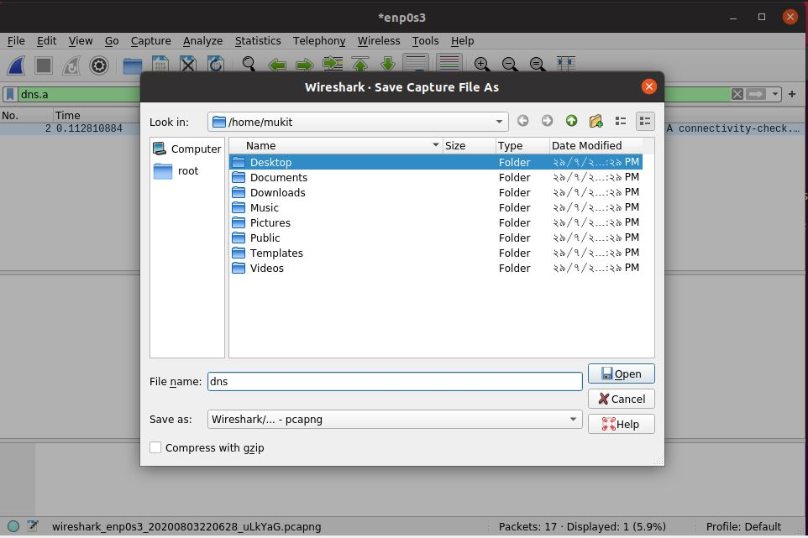

The file should be saved

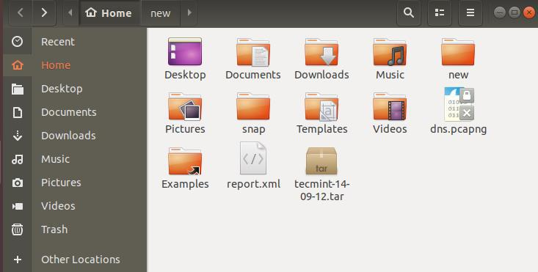

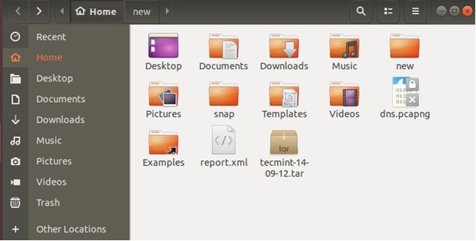

That’s how you install and use Wireshark in Linux.